Platte Center City Wide Garage Sales 2022
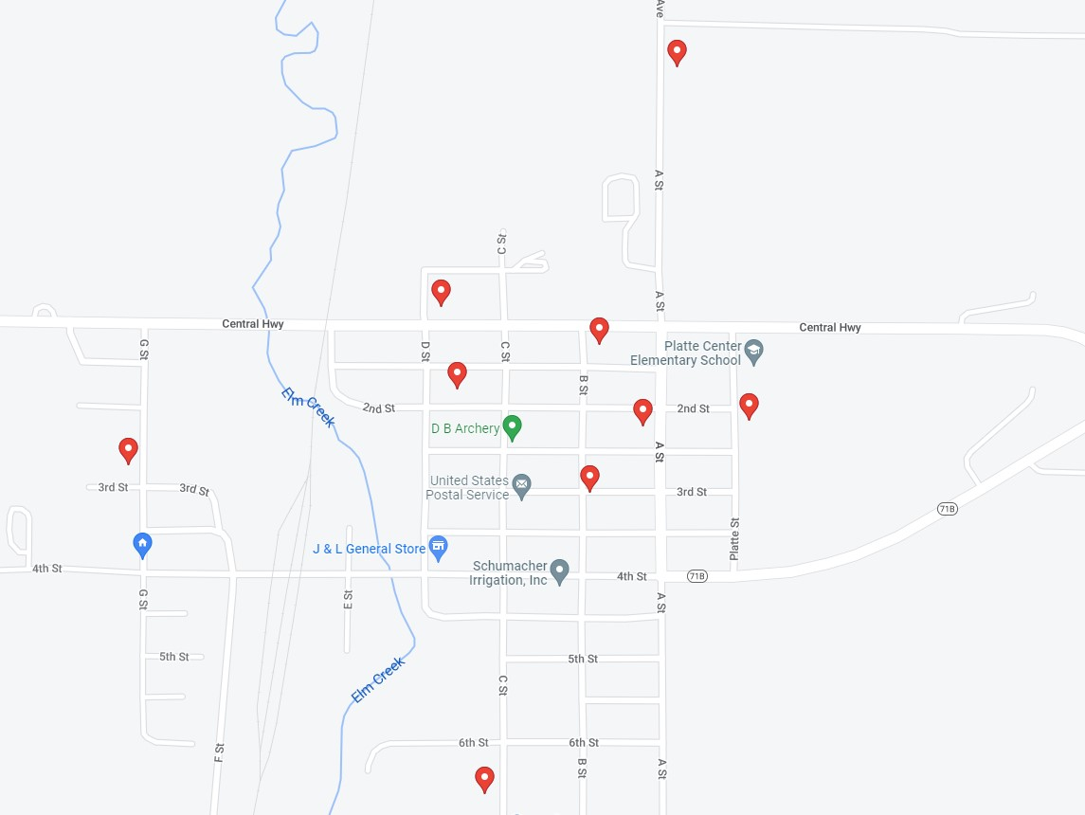
- 117 E 3rd Street – Household Items, adult & boys clothing & shoes. Games, toys, & more!

- 256 N A Street – Women’s clothes, boys clothes, and house decorations

- 668 C Street- Miscellaneous household & collectible items

- 268 N G St- baby, toddler clothes and items, kids today, household items

- 291 North A Street – Many household items included king size bed

- 316 2 Street in the alley- Name brand clothing men’s and women’s. Purses, luggage,
books, small furniture, home décor, old doors & windows for crafts.

- 153 N B Street- furniture, sporting goods, home décor, young women’s clothing, teaching supplies, kids toys, luggage, bags

- 251 Platte St- holiday items, table & china hutch, dishes, candles, nativity set, Almost everything $1

- 314 1st St- Clothing, household items, décor, ETC.

